**Author Biography**

Authors are encouraged to add a biography (maximum 150 words) to the submission and publish it. This should be a single paragraph and should contain the following points:

1. Authors’ full names followed by current positions;
2. Education background including institution information and year of graduation (type and level of degree received);
3. Work experience;
4. Current and previous research interests;
5. Memberships of professional societies and awards received.

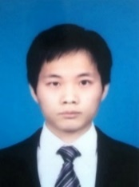

**Peng Xiao** He received the B.S degree in intelligent science and technology from School of Automation and Electronic Engineering, University of Science and Technology Beijing, China, in 2012. He is currently working on the PhD degree in communication and information engineering from the School of Computer and Communication Engineering, University of Science and Technology Beijing. His main research direction includes visual tracking, object detection, gaze estimation and natural language processing.

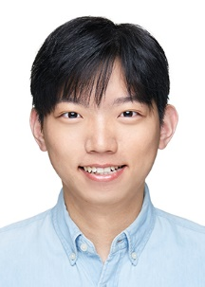**Jie Wu** He received the B.S. degree in measurement and control technology and instruments from School of Automation and Electronic Engineering, University of Science and Technology Beijing, China, in 2020, where he is currently pursuing the M.S. degree in instrument science and technology. His current research direction includes gaze estimation, image processing, eye tracking and system calibration. His main work is experiment and data collection.

Yu Wang

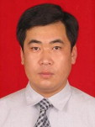**Jiannan Chi** received the B.S. degree in Optic Instrument Engineering, Tianjin University in 1990, Tianjin, China. In 2002, he graduated from Detection Technology and Automatic Equipment, Northeastern University with a M.S. degree. He received the Ph.D degree in Pattern Recognition and Intelligent System from the Northeastern University, 2005. He did post-doctoral research from 2005 to 2006 in University of Science and Technology, Beijing, China, where he is currently an associate professor in the Department of Instrument Science and Technology. He was a visiting scholar in Nanyang Technological University, Singapore, in 2011. His currently research interests include computer vision, human-computer interaction, and optical measurement, etc.

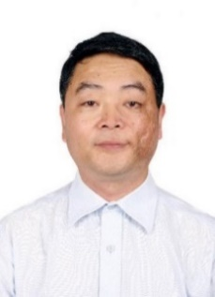

**Zhiliang Wang** received the M.S. degree from Yanshan University, Qinhuangdao, China, in 1982, and the Ph.D. degree from the Harbin Institute of Technology, Harbin, China, in 1989, both in control theory and control engineering. He is currently a Professor and the Doctorate Supervisor with the School of Computer and Communication Engineering, University of Science and Technology, Beijing, China. His research interests include security control of cyber-physical systems and active industrial control systems, and theory and application of networked control systems, and artificial intelligence. Dr. Wang is a Senior Board Member of the Chinese Association of Artificial Intelligence and the Director of the Beijing Society of Internet of Things.